**DDL**

1. Create table
2. Alter table
3. Drop – deletes whole table with all records
4. Truncate - deletes whole records in a table, it doesn’t deletes the table, delete also did this but the main difference between this two is we can specify where condition, when we tries to delete all the records with delete it takes a lot of time, because it deleted record one by one row wise.

**DML –** Delete, Insert, Update

**ADDING FOREIGN KEY TO EXISTING TABLE WITH ALTER**



**Adding primary key to existing table**



**Adding column to a existing table**



**Use of foreign key**

Helps to check if the entered value for a specific column is existing in other table, the value is not in that existing table we can have the following error.

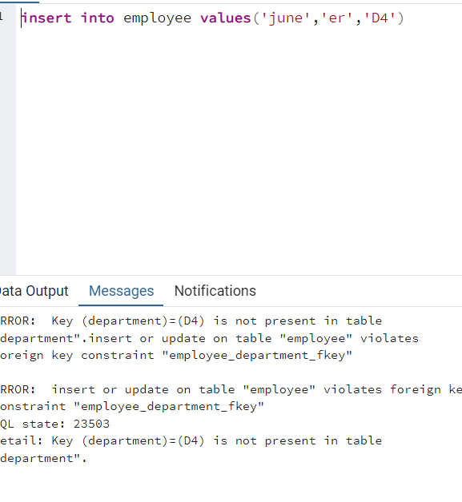

Because the below are the values we have in table department

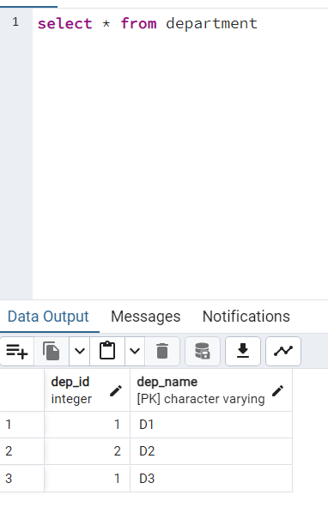

**Deleting a row in table**

When we are going to a record in department it is not deleted if it has a referenced values on parent table, Assume employee table has a values with department D1, when we are trying to delete this than the below error will come.

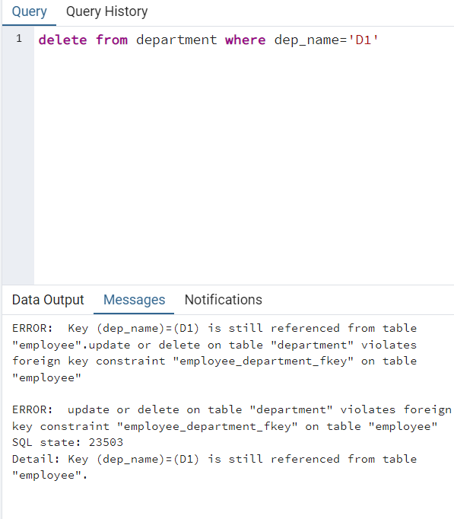

**CHECK CONSTRAINT:**

Helps to insert the valid data into the table, in below table the table allows to insert student who have the age greater than 18.

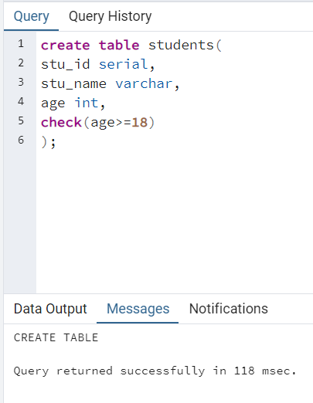

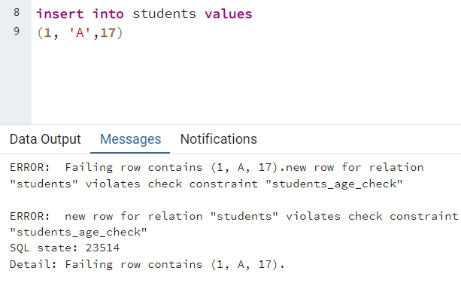

**TRUNCATE TABLE**

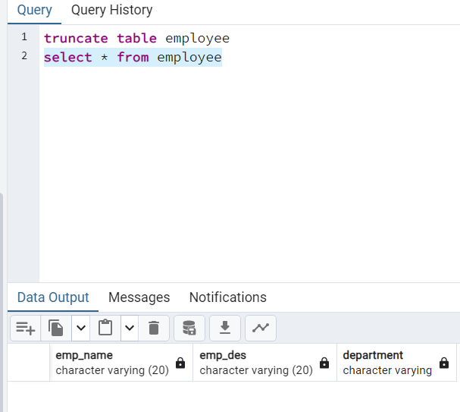

**ALTERING TABLE BY DROPING COLUMN, ALTERING TABLE COLUMN**

